# Song of the Week

The Song of the Week is “Ruby’s Shoes” by Lori McKenna.

**Reading**In reading we will begin a new comprehension unit on the strategy “Determining Importance”. We will learn how to read texts and decide if a piece of information is an interesting detail or important information that we need to understand. We will practice this strategy with non-fiction and fiction texts.   
**Writing**  
This week we will start our unit on persuasive writing. We will brainstorm things we want to change about the world. We will then use a graphic organizer (hamburger model) to plan out our opinion and reasons. We will use the planner to write our letters.  
**Math**This week we will continue to learn more strategies for double-digit subtraction.  
**Science**  
In Physics of Sound we will explore how sound travels through liquids, solids and gases.  
**Social Studies**  
In Social Studies this week we will begin a new unit on Civil Rights. We will learn about Martin Luther King Jr. and how he changed the world.  
**Vocabulary/Spelling**  
Our spelling words this week have the –ow and -ou spelling patterns. Our Spelling City website is: [www.spellingcity.com/kcheineman](http://www.spellingcity.com/kcheineman)

Monday, 1/18: Martin Luther King Day (no school)  
Thursday, 1/28: Field trip to Lifelife Theatre

*Students will not be penalized for not turning homework in. Math homework will be sent home M-Th so that parents are aware of what we’re studying.  
**Monday:** Read for 15 minutes, Math Sheet 5-5

**Tuesday:** Read for 15 minutes, Math Sheet 5-6

**Wednesday:** Read for 15 minutes, Math Sheet 5-7  
   
**Thursday:** Read for 15 minutes, Math Sheet 5-8

**Friday:** No homework

1.  flow

2.  below

3.  crow

4.  narrow

5.  shallow

6.  our

7.  out

8.  pout

9.  scout

10.  shout

challenge words:   
ourselves, mountain

# Weekly Spelling Words



# Weekly Homework



# This Week in Room 101

Mrs. Heineman’s Classroom Newsletter

Room 101

**Coonley Elementary**

**First Grade Options**

Monday, January 4th

2016

# Important Dates

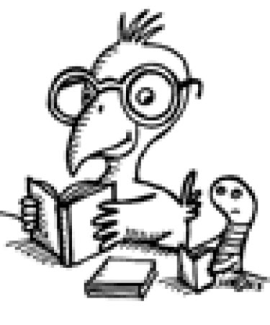

Super Star Scholar News