We will be practicing all of our songs this week for our Concert in the Classroom. Please come to hear all of our songs of the week performed live in the classroom on Feb. 26th at 8:45am

# Song of the Week

**Reading**In reading we will work on our song interpretations for the upcoming Concert in the Classroom this Friday.   
**Writing**  
This week we will publish our personal narratives. Students will be required to use at least three of the mentor author techniques that we have learned. We will use an editing and revising checklist to make sure we’ve included everything we need to in our published piece.  
**Math**This week we will begin Topic 8, which focuses on time and money.   
**Science**  
This week we will explore motion. We will explore how tops spin.   
**Social Studies**  
In Social Studies this week we will be studying Heroes who changed the world and writing about them in a book.   
**Vocabulary/Spelling**  
Our spelling words this week have the patterns –ue and –ie. Our Spelling City website is: [www.spellingcity.com/kcheineman](http://www.spellingcity.com/kcheineman)

Friday, 2/26: Concert in the Classroom, 8:45am (parents invited)  
Wednesday, 3/16: Field Trip to Raven Theatre to see “Aesops Fables”  
Friday, 4/8: No school for students  
Monday, 4/18-Friday, 4/22: Spring Break

*Students will not be penalized for not turning homework in. Math homework will be sent home M-Th so that parents are aware of what we’re studying.  
**Monday:** Read for 15 minutes, Math Sheet 8-1

**Tuesday:** Read for 15 minutes, Math Sheet 8-2  
  
**Wednesday:** Read for 15 minutes, Math Sheet 8-3  
  
**Thursday:** Read for 15 minutes, Math Sheet 8-4

**Friday:** No HW

1.  cue

2.  due

3.  hue

4.  clue

5.  glue

6.  lie

7.  pie

8.  dried

9.  tie

10.  tried

Challenge words: pursue, pried

# Weekly Spelling Words



# Weekly Homework



# This Week in Room 101

Mrs. Heineman’s Classroom Newsletter

Room 101

**Coonley Elementary**

**First Grade Options**

Monday, February 22nd

2016

# Important Dates

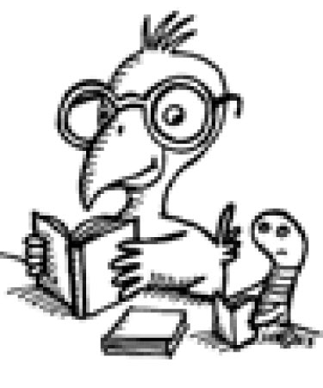

Super Star Scholar News