*Students will not be penalized for not turning homework in. Math homework will be sent home M-Th so that parents are aware of what we’re studying.  
**Monday:** Read for 15 minutes, Math Sheet 11-5

**Tuesday:** Read for 15 minutes, Math Sheet 11-6  
  
**Wednesday:** Read for 15 minutes, Math Practice Test due Friday

**Thursday:** Read for 15 minutes, Math Practice Test

**Friday:** No Homework

Monday 5/2-Friday 5/6- Celebration Week  
Wednesday, 5/25: Field trip to Botanic Gardens  
Thursday, 5/26: Field trip to Kent Prairie   
Monday, 5/30: No School, Memorial Day

**Reading**This week, we will begin our class novel, Frindle. We will meet the main character and see how he manages to create new words all by himself.

**Writing**  
We are continuing our how-too books this week. We will add transition words and text features to give our writing more clarity.

**Math**We will work with subtraction regrouping strategies this week. On Friday, we will take the Topic 11 assessment.

**Science**

In science, we will learn about how to care for the chicks once they hatch. We will also continue to monitor the development of the chicks each day and complete our habitats dioramas.

**Social Studies**  
In Social Studies this week we will review what we have learned about the pioneers. We will decide if we would choose to move west like the pioneers did.

**Vocabulary/Spelling**  
Our spelling words this week are adverbs ending in -ly. Our Spelling City website is: [www.spellingcity.com/kcheineman](http://www.spellingcity.com/kcheineman)

1. loudly
2. sadly
3. slowly
4. quickly
5. softly
6. gladly
7. greatly
8. badly
9. happily
10. carefully

Challenge words: beautifully,

peacefully

# http://www.polyvore.com/cgi/img-thing?.out=jpg&size=l&tid=8994897Weekly Spelling Wordshttp://www.polyvore.com/cgi/img-thing?.out=jpg&size=l&tid=8994897

# Weekly Homework



# This Week in Room 101

Mrs. Heineman’s Classroom Newsletter

Room 101

**Coonley Elementary**

**First Grade Options**

Monday, May 2nd

2016

# Important Dates

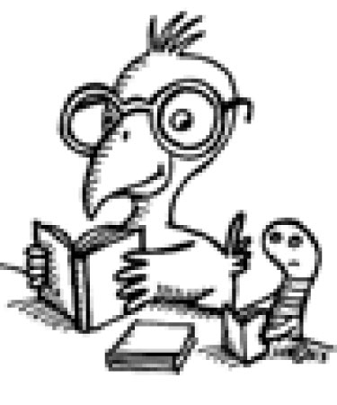

Super Star Scholar News