*Students will not be penalized for not turning homework in. Math homework will be sent home M-Th so that parents are aware of what we’re studying.  
**Monday:** Read for 15 minutes, Math Sheet 12-9

**Tuesday:** Read for 15 minutes, Math Practice Test due Thursday  
  
**Wednesday:** Read for 15 minutes, Math Practice Test

**Thursday:** Read for 15 minutes, No Math

**Friday:** No Homework

Wednesday, 5/25: Field trip to Botanic Gardens  
Thursday, 5/26: Field trip to Kent Prairie   
Monday, 5/30: No School, Memorial Day

Friday, 6/3: Dance Performance

Monday, 6/13: Beyond Words projects due

Friday, 6/17: First Grade Picnic

**Reading**We have finished reading Frindle and will do some closing activities this week. We will review the major events in the book and think about how they have affected the characters. We will also practice have small group discussions as a way to respond to reading.

**Writing**  
In writing, we will share our how-to books. We will also begin some autobiographical writing to close out the year, beginning with Six Word Memoirs. Every student at Coonley will contribute at least one memoir to celebrate the end of the year.

**Math**During this week’s math lessons, we will review what we have learned about measurement in preparation for the Topic 12 assessment on Thursday.

**Science**

We are working in groups to develop our questions and hypotheses for Science Fair. Each group will investigate a different question related to floating and sinking. This week we will brainstorm properties that may affect buoyancy to develop the questions we will investigate.

**Social Studies**

In social studies, we are focusing on the photo *Migrant Mother* as an example of art that brings awareness to a cause.

**Vocabulary/Spelling**  
Our spelling words this week are words we frequently misspell. Our Spelling City website is: [www.spellingcity.com/kcheineman](http://www.spellingcity.com/kcheineman)

1. again
2. always
3. could
4. friend
5. know
6. said
7. should
8. what
9. would
10. very

Challenge words: brought,

people

# http://www.polyvore.com/cgi/img-thing?.out=jpg&size=l&tid=8994897Weekly Spelling Wordshttp://www.polyvore.com/cgi/img-thing?.out=jpg&size=l&tid=8994897

# Weekly Homework



# This Week in Room 101

Mrs. Heineman’s Classroom Newsletter

Room 101

**Coonley Elementary**

**First Grade Options**

Monday, May 23rd

2016

# Important Dates

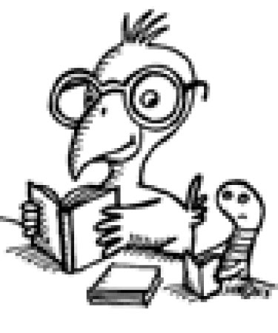

Super Star Scholar News