**Ms. Morgan’s email sasmith7@cps.edu**

**Reading**In reading, we will explore wordless picture books and how they communicate with us. We will work on making our own wordless picture book.

**Writing**  
In writing, we will continue to work on and finish up our autobiography books. We are also working on some fun end of year writing things including a summer bucket list and a goodbye to 1st grade book.

**Math**We will begin the Step up to 3rd grade unit. This unit is a preview of next year and introduces them to multiplication and division by using repeated addition and arrays.

**Science**

We will be presenting our Science Fair projects to the rest of the class this week.

**Social Studies**

In social studies, we will work in groups to discuss our causes and plan for our photos. We didn’t have a lot of time for Social Studies last week as we spent most of the week getting our Science Fair boards written up and ready to go.

**Vocabulary/Spelling**  
We will not have spelling words this week since we have Field Day Thursday and the 1st grade picnic on Friday.

Since this is the Step up to 3rd grade chapter in Math there isn’t a tear out homework page that goes along with it. Next year there will be, but it isn’t in the books they have now.   
**Monday:** Read for 15 minutes

**Tuesday:** Read for 15 minutes  
  
**Wednesday:** Read for 15 minutes

**Thursday:** Read for 15 minutes

**Friday:** No Homework

Monday, 6/13: Beyond Words projects due

Thursday, 6/16: Field Day

Friday, 6/17: First Grade Picnic  
Tuesday, 6/21: Last Day of School

# http://www.polyvore.com/cgi/img-thing?.out=jpg&size=l&tid=8994897Weekly Spelling Wordshttp://www.polyvore.com/cgi/img-thing?.out=jpg&size=l&tid=8994897

# Weekly Homework



# This Week in Room 101

Mrs. Heineman’s Classroom Newsletter

Room 101

**Coonley Elementary**

**First Grade Options**

Monday, June 13th

2016

# Important Dates

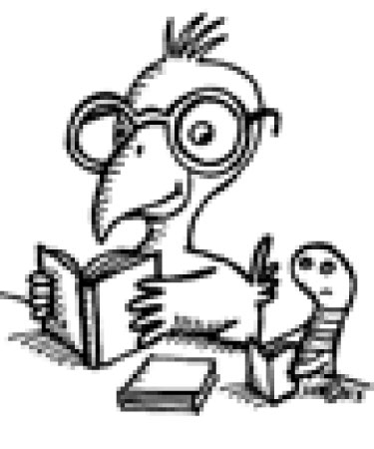

Super Star Scholar News